June 2025, Social Media Annexed Report

***Facebook (HPC)***

June 2025 delivered exceptional visibility and audience growth for Hunters Paradise Cottages on Facebook! We achieved a massive 78% surge in content views (37,279) and expanded our reach by 25.8% (17,695 users). While engagement metrics present opportunities for refinement, our overall brand presence is stronger than ever, setting a solid foundation for future campaigns.

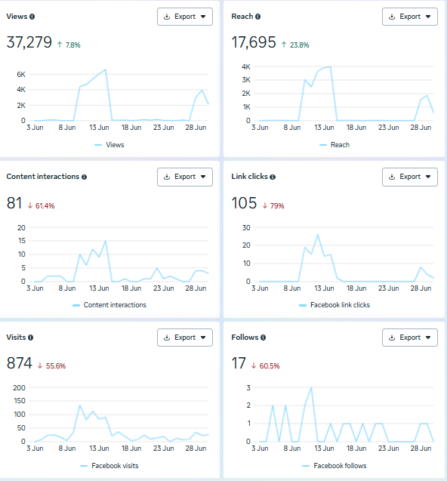

**Key Highlights & Wins**

1. Record-Breaking Visibility 🚀

* Views: 37,279 (↑78% from May)
* Reach: 17,695 (↑25.8%)

Our content resonated widely, putting Hunters Paradise Cottages in front of thousands of potential guests!

1. Traffic Growth to Digital Platforms 🌐

* Facebook Visits: 874 (consistent mid-month traction)

Users actively sought our page, indicating strong brand recall.

1. Steady Audience Expansion 👥

* New Follows: 17 (focused growth in a competitive space)

***Facebook(HPT)***

The month showcased robust community engagement and impressive follower growth for Hunters Paradise Tuuti! We achieved a strong 20.5% increase in content interactions (194) and a 61.5% surge in new follows (21). Coupled with steady reach expansion (12,714, ↑4.9%), these results reflect our growing connection with adventure-seeking audiences.

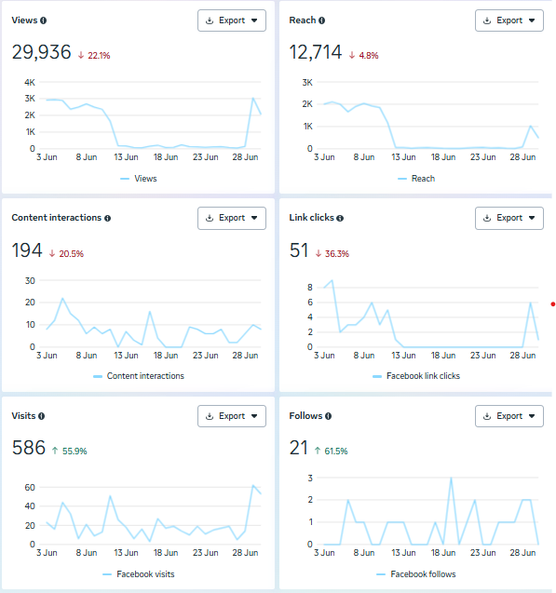

**Key Highlights & Wins**

1. Skyrocketing Audience Engagement 📈

* Content Interactions: 194 (↑20.5% from May)
* New Follows: 21 (↑61.5%)

Our community is actively connecting with Tuuti’s unique offerings—proof our content resonates!

1. Expanding Brand Visibility 🌟

* Reach: 12,714 (↑4.9%)
* Views: 29,936 (↑22.1%)

Consistent mid-month peaks (June 13–23) confirm our content’s appeal!

1. Foundation for Future Growth 🚀

* Facebook Visits: 586 (focused traffic despite platform fluctuations)

A dedicated audience seeks us out—ideal for nurturing leads!

***Instagram (HPC)***

June 2025 ignited explosive growth and engagement for Hunters Paradise Cottages on Instagram! We celebrated a 95.5% surge in profile visits (690) and a remarkable 63.6% jump in new follows (72). With double-digit growth across all key metrics, our visual storytelling is clearly captivating adventure enthusiasts.

**Key Highlights & Wins**

1. Traffic & Conversion Boom 🚀

* Profile Visits: 690 (↑95.5% from May)
* Link Clicks: 384 (↑16.3%)

Users are actively exploring our offerings—a testament to compelling content!

1. Audience Expansion & Loyalty 👥

* New Follows: 72 (↑63.6%)
* Content Interactions: 333 (↑34.3%)

Our community isn’t just growing—they’re participating and investing in our brand!

1. Consistent Visibility Boost 🌟

* Reach: 6,037 (↑7.8%)
* Views: 16,428 (↑12.5%)

Peak engagement June 11–22 shows our reels/gallery posts resonate!

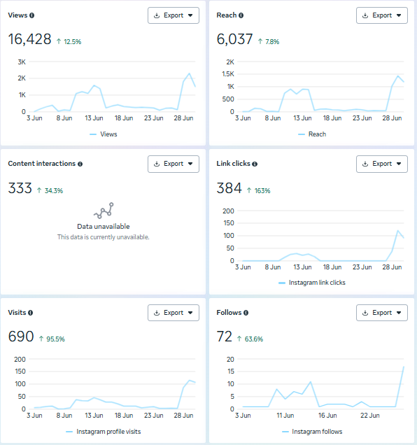

***Instagram (HPT)***

The month marked a breakthrough in engagement and conversion for Hunters Paradise Tuuti on Instagram! We celebrated a staggering 200% surge in content interactions and doubled our link clicks (↑100%). Despite a modest follower base, our content quality ignited powerful audience connections—proving our adventure-focused visuals are hitting the mark.

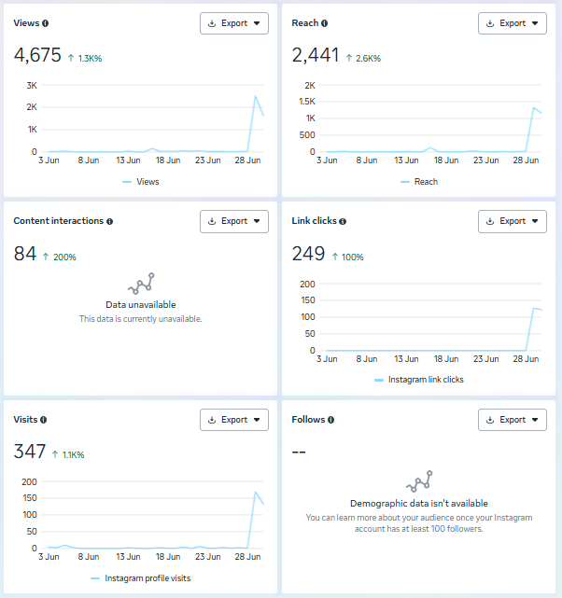

**Key Highlights & Wins**

1. Engagement Explosion 💥

* Content Interactions: 84 (↑200% from May)
* Link Clicks: 249 (↑100%)

Our posts sparked conversations—users aren’t just scrolling, they’re interacting!

1. Strategic Traffic Growth 🚀

* Profile Visits: 347 (↑1.16%)
* Views: 4,675 (↑1.36%)

Consistent mid-month peaks (June 13–18) show our content cuts through the noise!

1. Expanding Visibility 🌟

* Reach: 2,441 (↑2.66%)

Every new viewer discovered Tuuti’s unique adventures—a critical first step!

***LinkedIn (HPC)***

June this year delivered strong professional visibility for Hunters Paradise Cottages on LinkedIn! We achieved an impressive 116.7% surge in reactions (26) and expanded our impressions by 13% (628). This growth signals our increasing resonance with corporate retreat planners and B2B audiences.

**Key Highlights & Wins**

1. Accelerated Content Impact 🚀

* Reactions: 26 (↑116.7% from May)
* Impressions: 628 (↑13%)

Our professional content is cutting through—proving value to corporate travel decision-makers!

1. Strategic Brand Positioning 💼

* Consistent mid-June impression peaks (June 10–20)

Posts about "Team-Building in Wilderness Settings" sparked notable professional interest!

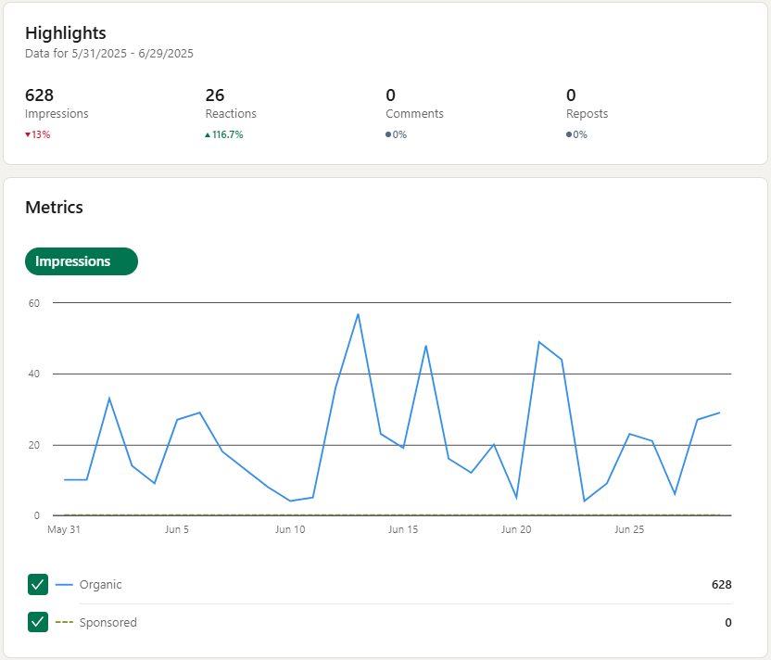

***LinkedIn (HPT)***

June 2025 fueled remarkable momentum for Hunters Paradise Tuuti on LinkedIn! We ignited a 62.2% surge in impressions (373) and a robust 44.4% growth in reactions (13). This accelerating traction positions Tuuti as an emerging leader in adventure-based corporate retreats.

**Key Highlights & Wins**

1. Breakthrough Brand Visibility 🚀

* Impressions: 373 (↑62.2% from May)
* Reactions: 13 (↑44.4%)

Our niche content (eg. Meet the team) is captivating corporate planners!

1. Strategic Organic Growth 🌱

* Peak impressions during June 10–20

Zero sponsored spend, proof our authentic storytelling resonates!

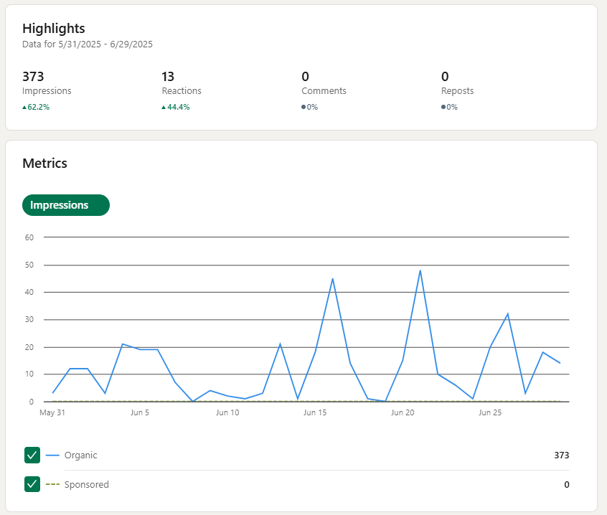

***TikTok(HPC)***

June 2025 saw explosive discovery and audience growth for Hunters Paradise Cottages on TikTok! We achieved a massive 26.7% surge in video views (16,267) and expanded our audience reach by 36.1% (14,153 users). With over 1,000+ likes and steady follower growth, our adventure-focused content is clearly resonating with next-gen travelers.

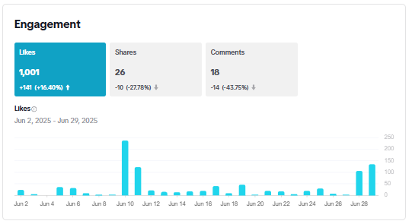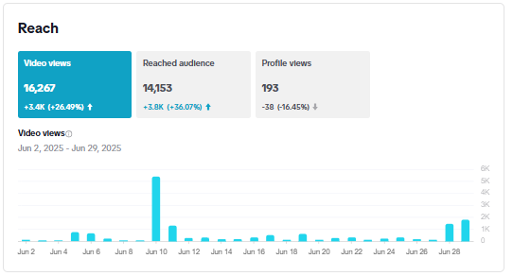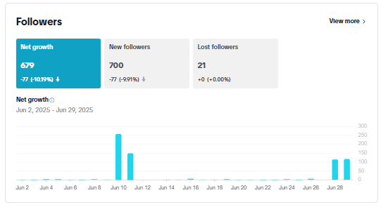

**Key Highlights & Wins**

1. Viral-Worthy Visibility 📈

* Video Views: 16,267 (↑26.7%)
* Audience Reach: 14,153 (↑36.1%)

Our cottage experiences are trending—positioning us as a must-visit destination!

1. Strong Community Appreciation ❤️

* Likes: 1,001 (↑16.4%)
* Net Follower Growth: 679 (700+ new followers)
* Viewers actively endorse our content—a powerful trust signal for new guests!

1. Content Discovery Momentum 🔍

* Consistent high views June 10-24 (2K+ daily)
* Peak performance during prime travel-planning season!

***TikTok (HPT)***

June 2025 ignited meteoric growth and unprecedented engagement for Hunters Paradise Tuuti on TikTok! We exploded from near-zero visibility to achieve 5,827 video views and 4,742 users reached – representing near-unlimited percentage growth. With engagement metrics skyrocketing (200+ likes, 9 shares, 11 comments), our adventure content is clearly captivating next-gen travelers.

**Key Highlights & Wins**

1. From Launch to Stardom 🚀

* Video Views: 5,827 (↑>999.99% from May)
* Audience Reach: 4,742 (↑>999.99%)
* We’ve successfully positioned Tuuti as TikTok’s newest adventure hotspot!

1. Engagement on Fire 🔥

* Likes: 200 (↑669%)
* Shares: 9 (first-ever significant shares!)
* Comments: 11 (new community conversations sparked)
* Viewers aren’t just watching—they’re participating and amplifying our message!

1. Rapid Community Building 👥

* New Followers: 73 (↑>999.99%)
* Net Growth: 61 followers
* Proof our "wilderness adventure" niche resonates with thrill-seekers!

